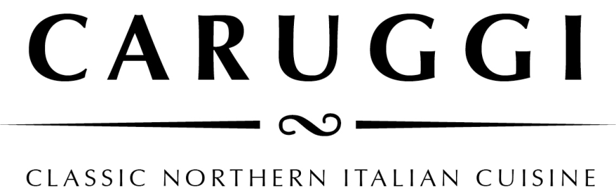
Lunch Menu

Focaccia col formaggio
A speciality from the chef’s hometown of Recco on the Ligurian Coast. This dish uses its own wafer thin in two layers dough filled with the tangy but creamy handmade crecenza cheese and baked in the pizza oven.
Classico 17.50 / 26.00
Finished with Pesto or rocket 16.50/ 26.50
finished with San Danielle prosciutto 19.50 /29.50 Pizzata- cooked with capers, olives, anchovies and tomato passata 17.50/ 27.50

Smaller dishes/ Sharing plates
Local and Italian olives warmed with chilli and herbs 9.00
Marinated white anchovies on a tomato salad 12.75
Portarlington mussels with fregola, fresh tomato, white wine, and chilli 19.50/ 28.50

Bresola Carpaccio with parmesan, sorrel, and celery in a lemon dressing 18.00

Baked Diavoletti – provolone cheese with an olive and chilli baked with radicchio and witlof 18.50

Trio of salumi with pickles and marinated mushrooms 27.50

A banking surcharge of 1.8% will be applied to your purchase by card

Pasta
Pansotti con salsa di noci- handmade pasta filled with silverbeet, herbs and curd served in an otway walnut pesto 27.50

Pizzoccheri – buckwheat pasta in butter and sage with Tuscan cabbage, potatoes, and asiago cheese 27.50

Pappardelle al ragu del giorno 29.50

Linguini con sepia nero 35.00
With mixed seafood, white wine, herbs, and bisque

Spaghetti Pesto alla Genovese with green beans and potatoes 18.50/ 26.50

Simple Spaghetti Napoli 17.50/24.00
Classic Spaghetti Bolognese 19.50/ 28.50
Sides
Rocket and Parmesan 10.00
Tomato, red onion, and basil 10.50
Leaves, pear, fresh pecorino and walnuts 11.00
Spinach, fennel, and sundried tomato 9.50
Mushroom and herb polenta with parmesan 9.5
Potato puree with parmesan 9.5
Broccolini with toasted pine nuts 10.00

