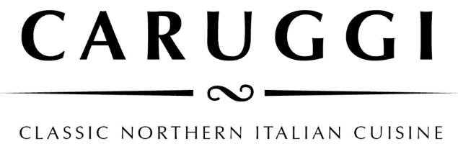

**Regional Identity - Italian Simplicity**

Massimiliano our owner and chef comes from the region of Liguria, a thin strip of land in Northern Italy where the mountains meet the sea, a cuisine based on fish from the small villages and taggiasche olives and olive oil, herbs and vegetables from the hills. We aim to deliver the simplicity of Northern Italian cuisine using the best of local and Italian produce.

**Buon Appetito**

**Typical Ligurian dishes are**

Focaccia col formaggio - Mussels - Anchovies - Pesto - Pansotti - Zuppa di pesce

**Buon Appitito**

To indulge in the Ligurian cuisine we recommend

Focaccia col formaggio - Mussels - Anchovies - Pesto - Pansotti - Zuppa di pesce

**Focaccia col formaggio**

Our speciality which originates from the chef’s hometown of Recco on the Ligurian Coast. This dish has two layers of wafer-thin dough filled with a creamy, tangy handmade cheese then baked in the pizza oven.

The original - Classico

With San Daniele prosciutto Pizzata- the classic version sprinkled with capers, olives, anchovies and passata

**Pizze**

**Piemontese**

Tomato, mozzarella, ham, mushrooms, and taleggio cheese

Calabrese

Tomato, mozzarella, salami soppressa, red pepper and olive

Valdostana

Tomato, mozzarella, fontina cheese, speck, finished with marinated wild mushrooms

Emiliana

Tomato, mozzarella, finished with prosciutto, rocket and shaved Grana Padano parmesan

**Lombarda**

Tomato, mozzarella, pumpkin, spinach, walnuts and gorgonzola

**Campania**

Tomato, mozzarella, smoked bocconcini, cherry tomato and oregano

Allergens

Please make us aware of any allergies or dietary requirements when ordering and we can talk you through menu items that will cater to you needs.

Gluten free means no pizza, however most of our pasta sauces can be made with gluten free pasta and the rest of the menu either is or can be adapted for gluten free diners

*A surcharge of 1.8% will be applied to all card transactions*

Lunch

**Have lunch on the Cinque Terre-**

**Ligurian inspired grazing plates**

**Our version of Chefs selection**

**Spuntino**

**Mixed Olives** warmed with chilli and herbs

**White anchovies**

on a tomato and red onion salad

**Daily Terrine**

served with marinated mushrooms

**Bresaola Carpaccio** with parmesan, sorrel, and celery in a lemon dressing

**Antipasti**

**Fior di latte**

with tomato, avocado and spinach Add prosciutto

**Smoked Duck** with parmesan, marinated mushrooms, leaves and boretane onions

**Bellarine Smoked Baramundi**

with capers, olives, fennel, radish and rocket

**Salumi Misti**

a mixed selection of Italian Doc meatswith pickled vegetables and marinated mushrooms

**Piatti Caldi- Warm Dishes**

**Sauteed Portarlington mussels** with fregola, fresh tomato, white wine, and chilli

**Chicken alla Romana,** withlemon and herbs,potatoes, olives, and artichoke

**Cottechino sausage** served with lentils, friarelli and Brussel sprouts

**Panfried quail**

served with sauteed potatoes, mushrooms and spinach

Please ask for our daily dishes and bistro lunch of the day



**Pasta**

**Pansotti con salsa di noci**- handmade pasta filled with silverbeet, herbs and curd served in an otway walnut pesto

**Pasta al Pesto Genovese**

tossed with green beans and potatoes

**Smoked Red Pepper Rigatoni**

with pork and fennel sausage, broccoli and provolone cheese sauce

**Pappardelle** con al ragu del giorno

**Tagliolini al nero (** Squid ink fresh pasta **)** With mixed seafood, white wine, herbs, tossed in a lobster bisque

Simple **Spaghetti Napoli**

Classic **Spaghett**i **Bolognese**

**Sides**

Rocket and Parmesan

Tomato, red onion, and basil

Leaves, pear, fresh pecorino and walnuts

Spinach, fennel, and sundried tomato

Mushroom and herb polenta with parmesan

Broccolini with toasted almonds