*\*7*

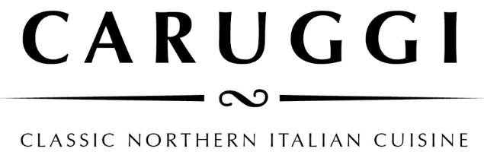

Dinner

**Focaccia col formaggio**

Our speciality which originates from the chef’s hometown of Recco on the Ligurian Coast. This dish has two layers of wafer-thin dough filled with a creamy, tangy handmade cheese then baked in the pizza oven.

The original - Classico 28/38

San Danielle prosciutto 34/42 Pizzata- the classic version sprinkled with capers, olives, anchovies and passata 32/39

**Regional Identity - Italian Simplicity**

Massimiliano our owner and chef comes from the region of Liguria, a thin strip of land in Northern Italy where the mountains meet the sea, a cuisine based on fish from the small villages and taggiasche olives and olive oil, herbs and vegetables from the hills. We aim to deliver the simplicity of Northern Italian cuisine using the best of local and Italian produce.

**Buon Appitito**

To indulge in Ligurian cuisine we recommend

Focaccia col formaggio - Mussels - Anchovies - Pesto - Pansotti - Zuppa di pesce

**Buon Appitito**

To indulge in the Ligurian cuisine we recommend

Focaccia col formaggio - Mussels - Anchovies - Pesto - Pansotti - Zuppa di pesce

**Spuntino and Antipasti**

**Mixed Olives** warmed with chilli and herbs 9

**Fior di Buratta**

with mixed grilled vegetables 19

Add prosciutto 22.5

**White anchovies** on a tomato salad 15

**Sauteed Portarlington mussels** with fregola, fresh tomato, white wine, and chilli 25

**Octopus, cuttlefish** and potato

with green beans and olives 22

**Vitello tonnato** – A classic Piemontese dish. 22

Thinly slice veal served with a creamy tuna sauce

**Daily Terrine**

served with marinated mushrooms 19

**Salumi Misti** with pickled vegetables and marinated mushrooms 28.5

**Secondi**

**Slow roasted** **Duck leg**

with roast potatoes and dutch carrots 40

**Chianti Braised** **Beef Cheek**

with polenta and sauteed greens 43

**Daily Fish Livornese style** – pan-fried with olives, pinenuts and cherry tomato in a prawn bisque reduction 42

Please ask for our daily specials



**Pasta**

**Pansotti con salsa di noci**- handmade pasta filled with silverbeet, herbs and curd served in an Otway walnut pesto 29.5

**Pasta al Pesto Genovese**  32.0

tossed with green beans and potatoes

**House made Pacheroni** with pancetta, olives, fresh tomato and scamorza cheese sauce 33.0

**House made Pappardelle** al ragù del giorno 36.0

**Tagliolini al nero (** freshpasta with **s**quid ink  **)**

With mixed seafood, white wine, herbs, tossed in a lobster bisque 38

Simple **Spaghetti Napoli**  25

Classic **Spaghett**i **Bolognese** 32

**Sides**

Rocket and Parmesan 11

Tomato, red onion, and basil 12.5

Leaves, pear, fresh pecorino and walnuts 12

Spinach, fennel, and sundried tomato 10.5

Mushroom and herb polenta with parmesan 9.5

Broccolini with toasted almonds 12

**Pizze**

**Piemontese** 29.5

Tomato, mozzarella, ham, mushrooms, and taleggio cheese

Calabrese 29.5

Tomato, mozzarella, salami soppressa, red pepper and olives

Valdostana 29.5

Tomato, mozzarella, fontina cheese, speck, finished with marinated wild mushrooms

Emiliana 31.5

Tomato, mozzarella, finished with prosciutto, rocket and shaved Grana Padano parmesan

**Lombarda** 28.5

Tomato, mozzarella, pumpkin, spinach, walnuts and gorgonzola

**Campania**  27.5

Tomato, mozzarella, smoked bocconcini, cherry tomatoes and origano

Allergens

Please make us aware of any allergies or dietary requirements when ordering and we can talk you through menu items that will cater to you needs.

Gluten free means no pizza, however most of our pasta sauces can be made with gluten free pasta and the rest of the menu either is or can be adapted for gluten free diners

*A surcharge of 1.8% will be applied to your card transaction*