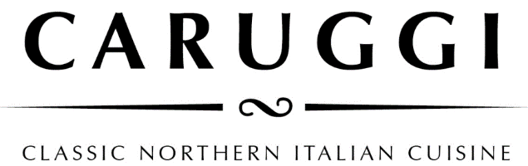

Grazing Options at Caruggi

Option 1- 55pp
( We normally allow one of each dish for 4 people to share and increase accordingly )
First wave
Focaccia col Formaggio
Vitello Tonnato
White Anchovies
Second Wave
Pizza
Trofie al Pesto
Pappardelle al Ragu od the day- or a short pasta to share

Option 2- 65pp
Add on Slow roast of the day- (eg Beef Cheeks- Osso Bucco )

Option 3- 75pp
Add on cannoli each or Tiramisu and Pannacotta to share

We can provide you with a celebration Tiramisu which is ideal for 8 to 10 people and is served in a trifle bowl

